Parth Babbar

Money-market accounts

**Introduction:**

Money Market Accounts (MMAs) are savings accounts that often provide greater interest rates than normal savings accounts. These accounts strike a compromise between collecting income and retaining liquidity, making them a popular choice for people who want both security and convenience. MMAs are offered through banks and credit unions, and they are guaranteed by the Federal Deposit Insurance Corporation (FDIC) or the National Credit Union Administration (NCUA), providing a secure location to hold money. However, MMAs sometimes have higher minimum balance restrictions and fewer transaction capabilities, which reflect their higher interest rates.

**Features of MMA:**

1. **Interest Rates:** Money Market Accounts (MMAs) typically provide better interest rates than ordinary savings accounts. These rates may fluctuate depending on the institution and current economic conditions. For example, in June 2024, the average interest rate for MMAs was roughly 0.75%, with certain banks offering rates more than 2.00% for high-balance accounts. Because of the volatility of interest rates, MMAs are an appealing alternative for investors wishing to maximise their returns while retaining the security and liquidity of their investments.
2. **Minimum Balance:** Money Market Accounts (MMAs) normally provide greater interest rates than traditional savings accounts, but they need a larger initial deposit, usually between $1,000 and $10,000. Account users must have a minimum balance to avoid monthly fees, which might outweigh the benefits of higher interest rates. Interest rates on MMAs fluctuate according on the institution and economic conditions; in June 2024, rates varied from around 0.35% to more than 2.00% for high-balance accounts. These accounts strike a compromise between earning potential and the need to keep cash accessible and secure.
3. **Liquidity:** Federal restrictions (Regulation D) often limit specific types of withdrawals and transfers from Money Market Accounts (MMAs) to six per month. This restriction was temporarily suspended in 2020 because to the COVID-19 pandemic. Many MMAs also offer check-writing capabilities and debit card access, allowing account users to easily access their funds when required.
4. **Insurance:** The Federal Deposit Insurance Corporation (FDIC) or the National Credit Union Administration (NCUA) insures Money Market Account (MMA) deposits up to $250,000 per depositor, each insured bank, and for each account ownership type. This insurance coverage ensures the safety and security of deposited cash.

**Benefits & Drawbacks:**

**Benefits:**

1. **Higher Interest Rates:** MMAs often offer higher yields than standard savings accounts, allowing savers to grow their cash more effectively.
2. **Safety:** With FDIC or NCUA insurance, depositors may be confident that their money is safe.
3. **Liquidity:** Despite certain transaction constraints, MMAs provide a high level of liquidity, providing for easy access to money.
4. **Convenience:** Features such as check-writing and debit card access offer the same flexibility as checking accounts.

**Drawbacks:**

1. **Minimum Balance Requirements:** Some savers may find it difficult to meet the higher minimum balance requirements.
2. **Monthly costs:** Failure to maintain the required balance may result in costs that diminish your overall return.
3. **Variable Interest Rates:** Interest rates might change in response to market conditions, reducing the predictability of returns.

**Statistics:**

1. **Market:** As per June 2024, the Total assets in MMA is worth $6.1 Trillion.  
   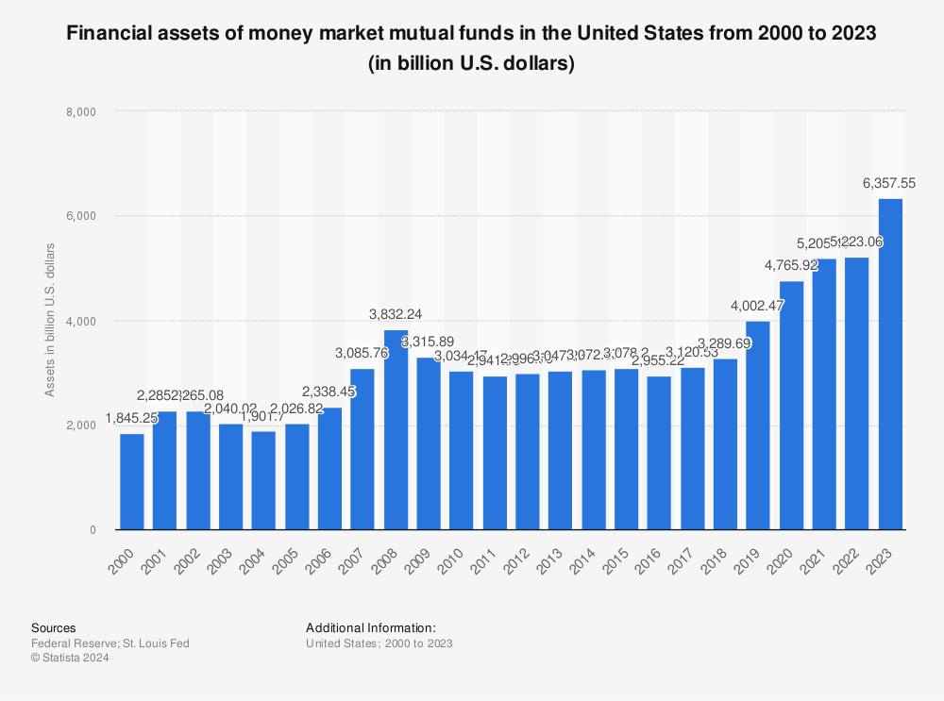

1. Over the last five years, MMA interest rates have fluctuated, with a noteworthy increase from 0.12% in early 2020 to over 0.75% in mid-2024, impacted by changes in the Federal Reserve's monetary policy.
2. Major banks and credit unions that provide competitive MMA rates include Ally Bank, Capital One, Discover Bank, and Navy Federal Credit Union.

**Conclusion:**

Money Market Accounts are an appealing alternative for depositors seeking greater interest rates while keeping liquidity and security. MMAs combine the benefits of savings and checking accounts by offering FDIC or NCUA protection as well as amenities such as check-writing and debit card access. However, potential account holders should carefully analyse the minimum balance requirements and associated fees to ensure that an MMA is appropriate for their financial objectives and circumstances.